ASSIGNMENT-1:

* python script to connect with MongoDB and the CRUD Operations.

Mongo DB server credentials

* Port number-27010
* Default IP: 127.0.0.1
  + MongoDB is the DB Server
  + mongo/mongosh (clients – non-programmable)
  + pymongo(Driver – programmable client)
* To install use -----pip install pymongo in command prompt

1. Now create a folder on desktop with a file named app.py in it through vs code
2. Write a script to connect with mongoDB and read the data.

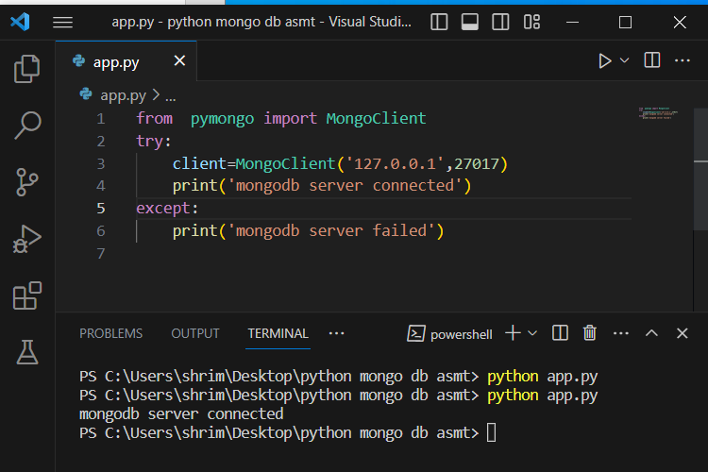

1. Now connecting of database

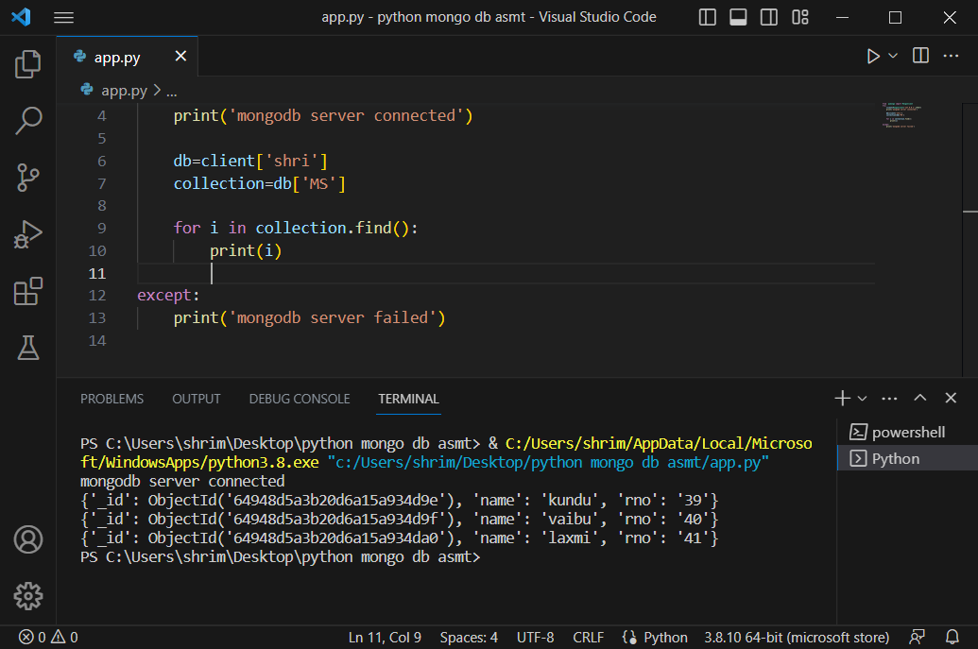

1. For inserting a document in collection

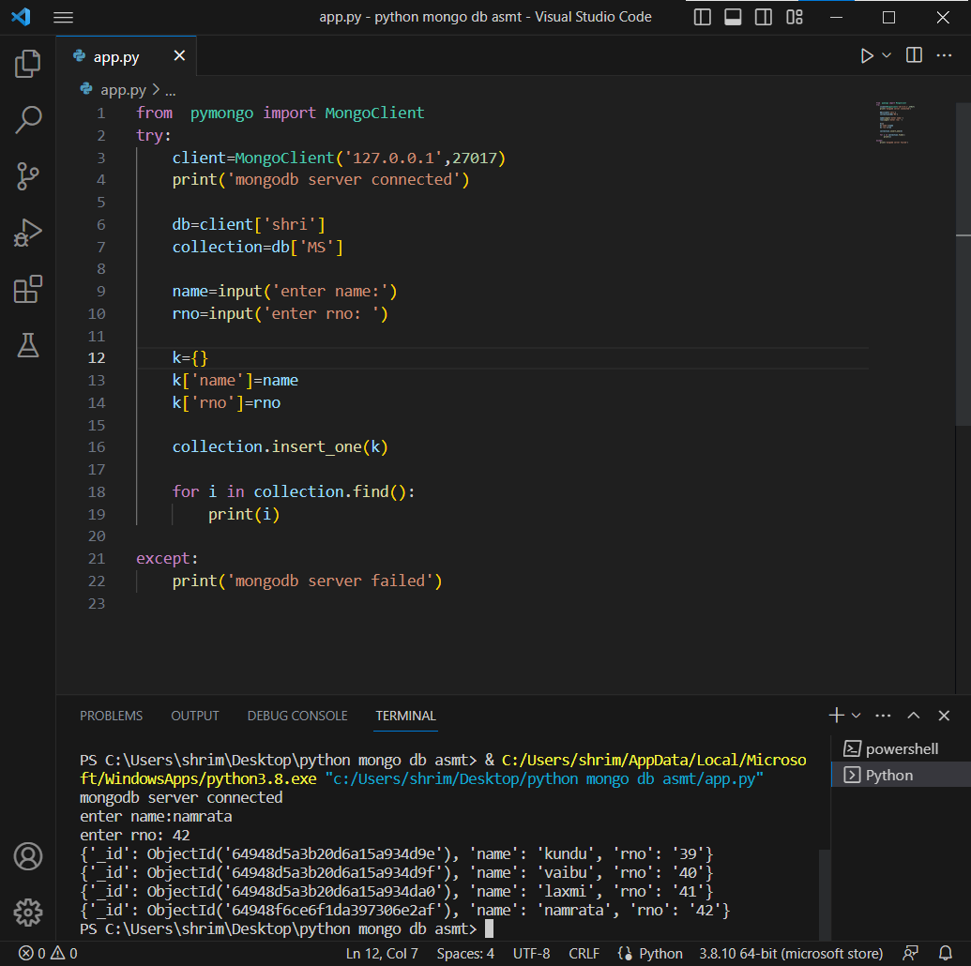

1. To insert one doc and to fetch only that document

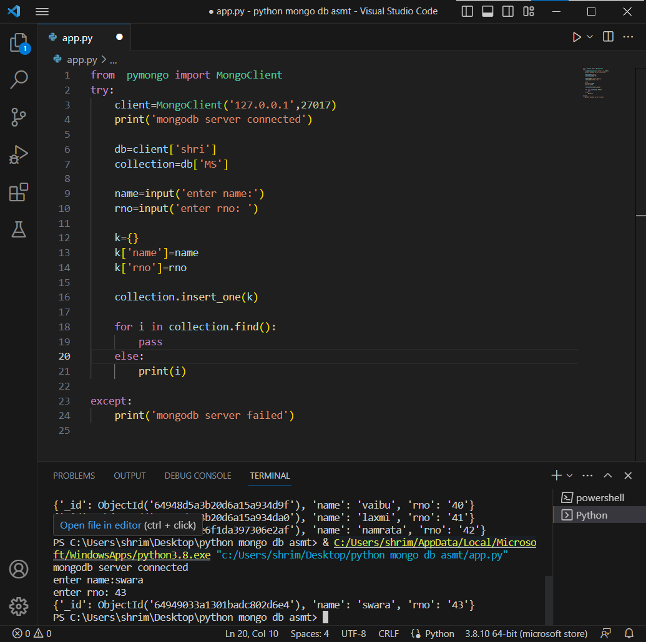

1. To pass the query and fetch the document

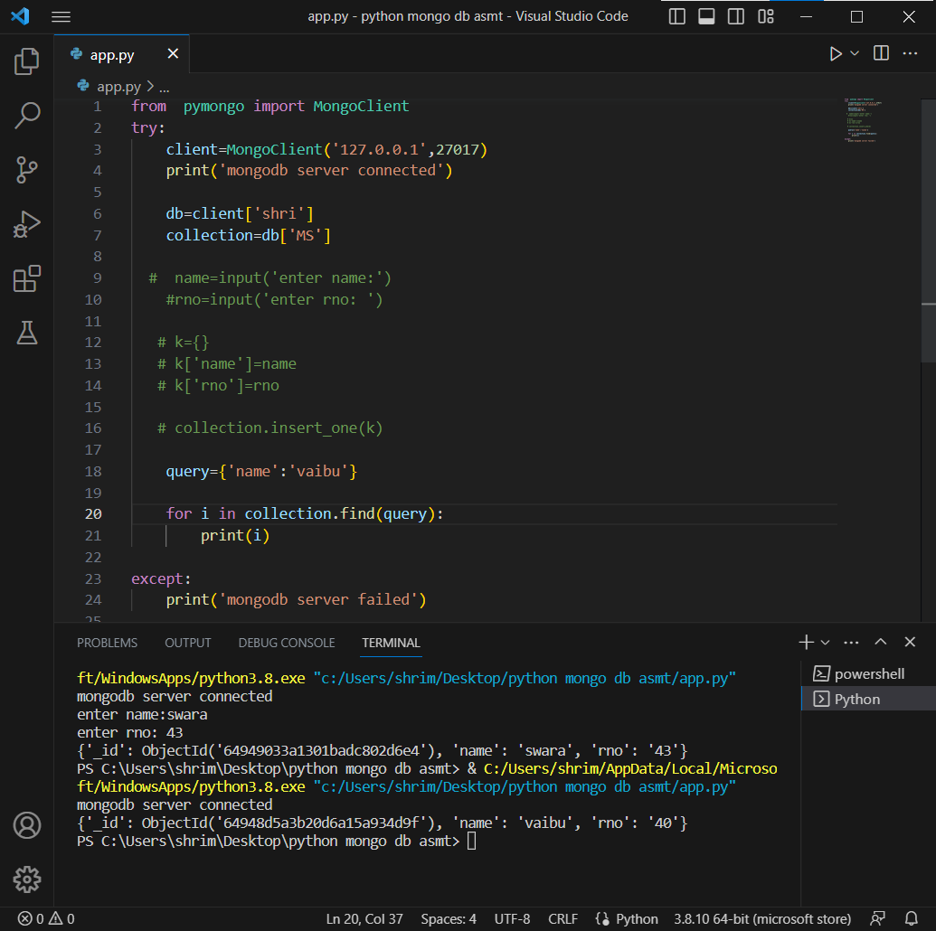

1. Updating a document

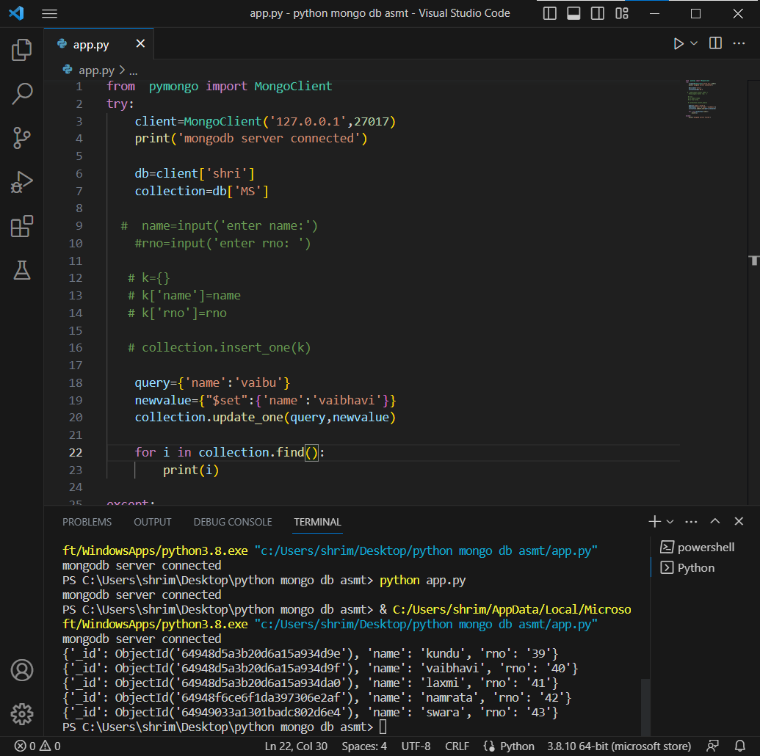

1. Deleting a document

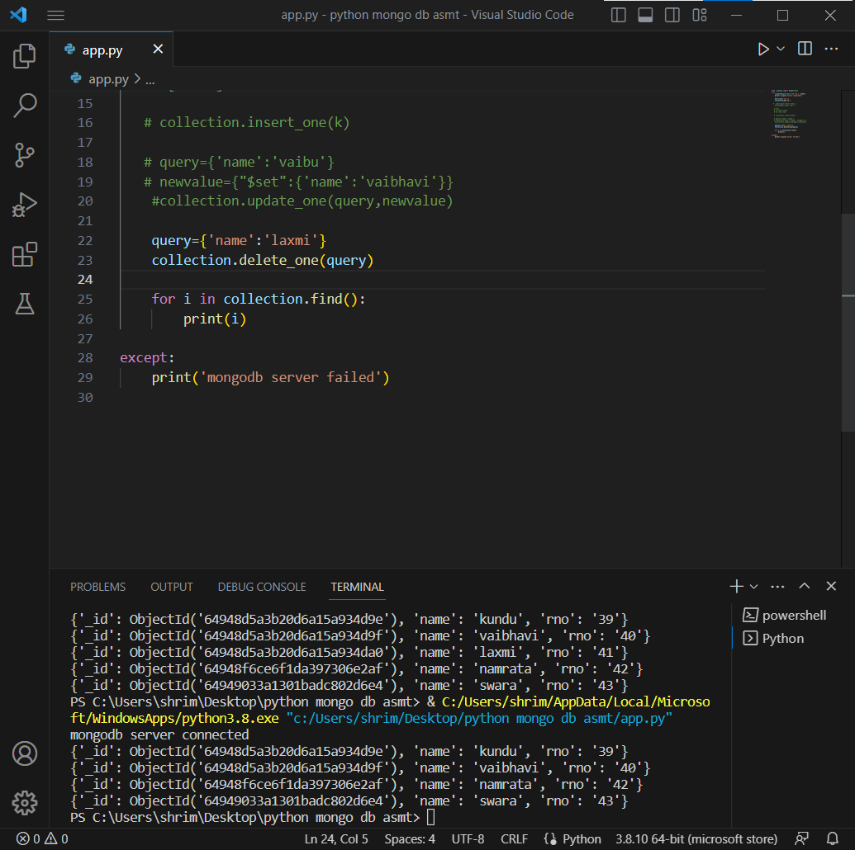

SYNTAX’S

* + Syntax to connect with database: Client=MongoClient(‘127.0.0.1’,27017)
  + Syntax to create database: db = client[‘dbname’]
  + Syntax to create collection: collection = db[‘collectionname’]
  + Syntax to insert document: collection.insert_one(document)
  + Syntax to read all documents: for a in collection.find():

print(a)

* + Syntax to create a query: query = {‘name’:’value’}

for a in collection.find(query):

print(a)

* + Syntax to update a query:

query = {‘name’:’value’} newvalue = {“$set”:{‘name’:’newvalue’}} collection.update_one(query,newvalue)

* + Syntax to delete a query:

query = {‘name’:’value’}

collection.delete_one(query)